***AMERICAN INTERNATIONAL UNIVERSITY OF BANGLADESH***

**PROJECT: Coffee Shop Management System**

**COURSE :**  **INTRODUCTION TO DATABASE**

**COURSE TEACHER:** **SIFAT RAHMAN AHONA**

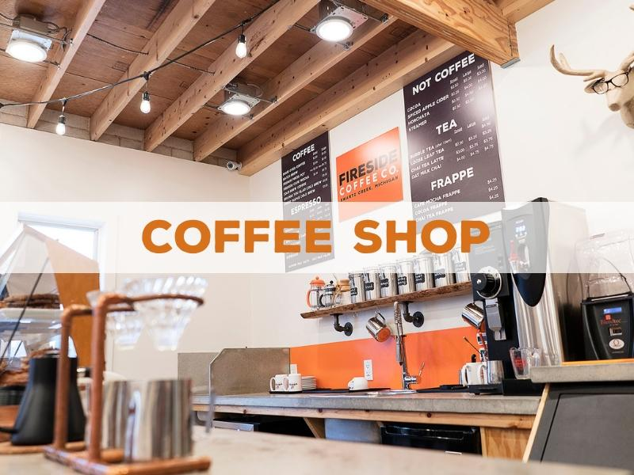

|  |  |  |  |
| --- | --- | --- | --- |
|  |  |  |  |
| **NO** | **NAME** | **ID** | **SECTION** |
| **01** | **MD RIYAD MAHMUD** | **18-38438-2** | **C** |
| **02** | **RAHUL SAHA** | **18-38439-2** | **C** |
| **03** | **SAJAN DATTA** | **18-38607-2** | **C** |
| **04** |  |  | **C** |

**INTRODUCTION :**

The purpose of the coffee shop does sometimes take on the purpose of the centre of society. Your visit could be to meet up or gossip with your friends, do some works, read a book, entertain, or simply to just pass some time. It can be one place that will be a great meeting ground. On the other hand many people start earlier in the morning with a strong coffee and make themselves refresh. So, a coffee shop is there destination in morning or during the whole day.

**CASE STUDY :**

A Coffee Shop recognized by Shop Name, Address, Phone number, shop regi_id and email. Every Coffee Shop has an Owner who owns the Coffee Shop. The Owner identify by his/her name, Address, ID, Phone number, Email. The Owner appoint a manager to manage the Coffee Shop. He has also a unique id, Name, Phone number, Salary, Address, Email. The Manager Manages his Coffee Shop and also maintains his employees. Employees recognized by unique id, name. Employees phone number, Address, Email, Salary and Hire_date has also recorded to Manager. In a Coffee shop Customer often visited. Therefore, their name, default id recorded in the system. After spend their time and finished their coffee they pay bill. Bill has bill_number, descrptition, time, date , total amount .that is how a coffee shop management system run .

**ER-DIAGRAM:**

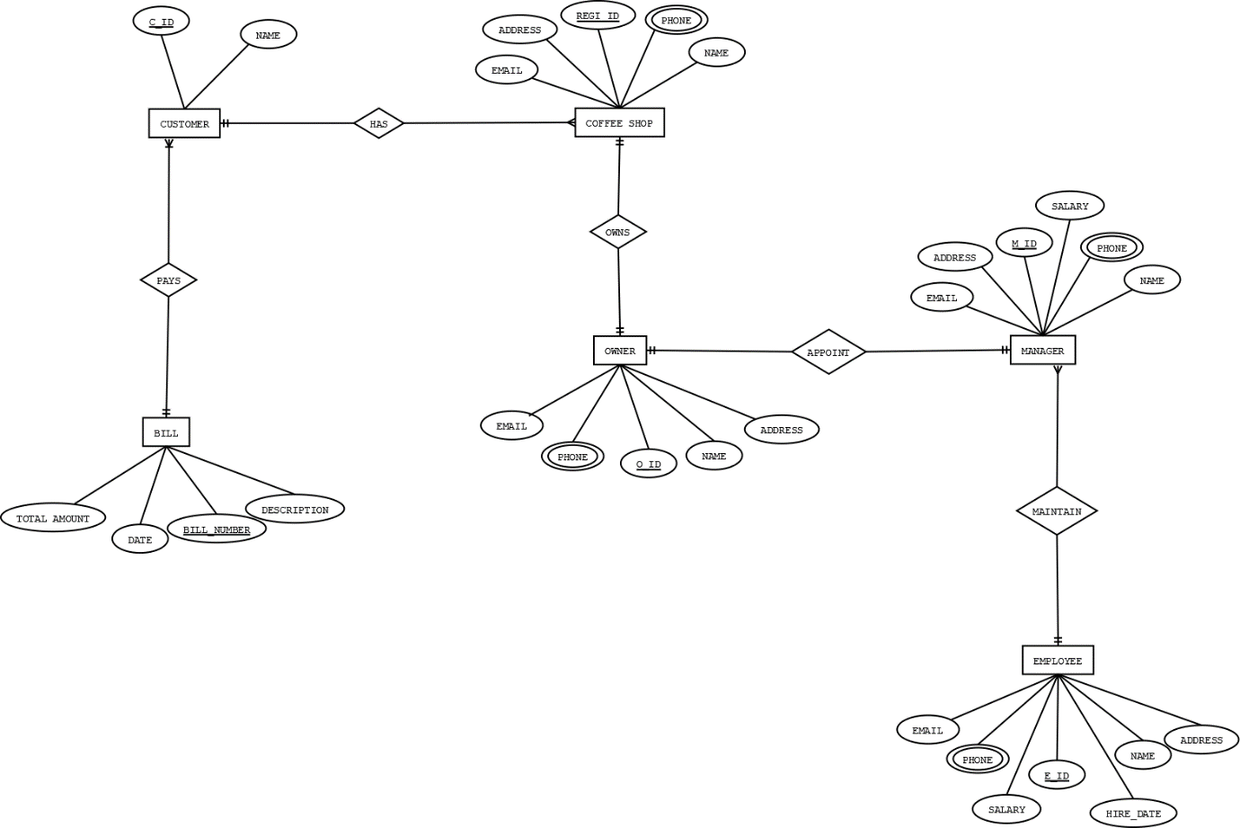

**NORMALIZATION:**

**OWNS**

|  |  |  |  |  |  |  |  |  |  |
| --- | --- | --- | --- | --- | --- | --- | --- | --- | --- |
| **Regi_id** | **address** | **Phone** | **email** | **name** | **O_id** | **name** | **phone** | **email** | **address** |

**1NF:**

|  |
| --- |
| **PHONE** |

**2NF:**

|  |  |  |  |  |  |
| --- | --- | --- | --- | --- | --- |
| **REGI_ID** | **NAME** | **ADDRESS** | **PHONE** | **EMAIL** | **O_ID** |

|  |  |  |  |  |
| --- | --- | --- | --- | --- |
| **O_ID** | **NAME** | **EMAIL** | **PHONE** | **ADDRESS** |

**3NF:**

|  |  |  |  |  |  |
| --- | --- | --- | --- | --- | --- |
| **REGI_ID** | **NAME** | **ADDRESS** | **PHONE** | **EMAIL** | **O_ID** |

|  |  |  |  |  |
| --- | --- | --- | --- | --- |
| **O_ID** | **NAME** | **EMAIL** | **PHONE** | **ADDRESS** |

**TABLE:**

**1.**

|  |  |  |  |  |  |
| --- | --- | --- | --- | --- | --- |
| **REGI_ID** | **NAME** | **ADDRESS** | **PHONE** | **EMAIL** | **O_ID** |

**2.**

|  |  |  |  |  |
| --- | --- | --- | --- | --- |
| **O_ID** | **NAME** | **EMAIL** | **PHONE** | **ADDRESS** |

**appoint:**

|  |  |  |  |  |  |  |  |  |  |  |
| --- | --- | --- | --- | --- | --- | --- | --- | --- | --- | --- |
| **O_id** | **name** | **phone** | **email** | **address** | **m_id** | **phone** | **name** | **address** | **email** | **salary** |

**1nf:**

**PHONE**

**2NF:**

|  |  |  |  |  |
| --- | --- | --- | --- | --- |
| **O_id** | **Phone** | **Email** | **name** | **address** |

|  |  |  |  |  |  |  |
| --- | --- | --- | --- | --- | --- | --- |
| **M_ID** | **NAME** | **PHONE** | **SALARY** | **ADDRESS** | **EMAIL** | **O_ID** |

**3NF:**

|  |  |  |  |  |
| --- | --- | --- | --- | --- |
| **O_id** | **Phone** | **Email** | **name** | **address** |

|  |  |  |  |  |  |  |
| --- | --- | --- | --- | --- | --- | --- |
| **M_ID** | **NAME** | **PHONE** | **SALARY** | **ADDRESS** | **EMAIL** | **O_ID** |

**TABLE:**

**1.**

|  |  |  |  |  |
| --- | --- | --- | --- | --- |
| **O_id** | **Phone** | **Email** | **name** | **address** |

**2.**

|  |  |  |  |  |  |  |
| --- | --- | --- | --- | --- | --- | --- |
| **M_ID** | **NAME** | **PHONE** | **SALARY** | **ADDRESS** | **EMAIL** | **O_ID** |

**MAINTAIN:**

|  |  |  |  |  |  |  |  |  |  |  |  |  |
| --- | --- | --- | --- | --- | --- | --- | --- | --- | --- | --- | --- | --- |
| **M_ID** | **NAME** | **PHONE** | **SALARY** | **ADDRESS** | **EMAIL** | **e_ID** | **NAME** | **ADDRESS** | **EMAIL** | **PHONE** | **SALARY** | **HIRE_DATE** |

**1NF:**

**PHONE**

**2NF:**

|  |  |  |  |  |  |  |
| --- | --- | --- | --- | --- | --- | --- |
| **M_ID** | **NAME** | **PHONE** | **SALARY** | **ADDRESS** | **EMAIL** | **e_ID** |

|  |  |  |  |  |  |  |
| --- | --- | --- | --- | --- | --- | --- |
| **e_ID** | **NAME** | **ADDRESS** | **EMAIL** | **PHONE** | **SALARY** | **HIRE_DATE** |

**3NF:**

|  |  |  |  |  |  |  |
| --- | --- | --- | --- | --- | --- | --- |
| **M_ID** | **NAME** | **PHONE** | **SALARY** | **ADDRESS** | **EMAIL** | **e_ID** |

|  |  |  |  |  |  |  |
| --- | --- | --- | --- | --- | --- | --- |
| **e_ID** | **NAME** | **ADDRESS** | **EMAIL** | **PHONE** | **SALARY** | **HIRE_DATE** |

**TABLE:**

**1.**

|  |  |  |  |  |  |  |
| --- | --- | --- | --- | --- | --- | --- |
| **M_ID** | **NAME** | **PHONE** | **SALARY** | **ADDRESS** | **EMAIL** | **e_ID** |

**2.**

|  |  |  |  |  |  |  |
| --- | --- | --- | --- | --- | --- | --- |
| **e_ID** | **NAME** | **ADDRESS** | **EMAIL** | **PHONE** | **SALARY** | **HIRE_DATE** |

**HAS:**

|  |  |  |  |  |  |  |
| --- | --- | --- | --- | --- | --- | --- |
| **REGI_ID** | **NAME** | **ADDRESS** | **EMAIL** | **PHONE** | **C_ID** | **NAME** |

**1NF:**

**PHONE**

**2NF:**

|  |  |  |  |  |  |
| --- | --- | --- | --- | --- | --- |
| **REGI_ID** | **NAME** | **ADDRESS** | **EMAIL** | **PHONE** | **C_ID** |

|  |  |
| --- | --- |
| **C_ID** | **NAME** |

**3NF:**

|  |  |  |  |  |  |
| --- | --- | --- | --- | --- | --- |
| **REGI_ID** | **NAME** | **ADDRESS** | **EMAIL** | **PHONE** | **C_ID** |

|  |  |
| --- | --- |
| **C_ID** | **NAME** |

**TABLE:**

**1.**

|  |  |  |  |  |  |
| --- | --- | --- | --- | --- | --- |
| **REGI_ID** | **NAME** | **ADDRESS** | **EMAIL** | **PHONE** | **C_ID** |

**2.**

|  |  |
| --- | --- |
| **C_ID** | **NAME** |

**PAYS:**

|  |  |  |  |  |  |
| --- | --- | --- | --- | --- | --- |
| **C_ID** | **NAME** | **BILL_NUMBER** | **DESCRIPTION** | **TOTALAMOUNT** | **DATE** |

**1NF:**

**NO MULTI VALUED ATTRIBUTE**

**2NF:**

|  |  |  |
| --- | --- | --- |
| **C_ID** | **NAME** | **BILL_NUMBER** |

|  |  |  |  |
| --- | --- | --- | --- |
| **BILL_NUMBER** | **DESCRIPTION** | **TOTALAMOUNT** | **DATE** |

**3NF:**

|  |  |  |
| --- | --- | --- |
| **C_ID** | **NAME** | **BILL_NUMBER** |

|  |  |  |  |
| --- | --- | --- | --- |
| **BILL_NUMBER** | **DESCRIPTION** | **TOTALAMOUNT** | **DATE** |

**TABLE:**

**1.**

|  |  |  |
| --- | --- | --- |
| **C_ID** | **NAME** | **BILL_NUMBER** |

**2.**

|  |  |  |  |
| --- | --- | --- | --- |
| **BILL_NUMBER** | **DESCRIPTION** | **TOTALAMOUNT** | **DATE** |

**TOTAL TABLE**

**1.**

|  |  |  |  |  |  |
| --- | --- | --- | --- | --- | --- |
| **REGI_ID** | **NAME** | **ADDRESS** | **PHONE** | **EMAIL** | **O_ID** |

**2.**

|  |  |  |  |  |
| --- | --- | --- | --- | --- |
| **O_ID** | **NAME** | **EMAIL** | **PHONE** | **ADDRESS** |

**3.**

|  |  |  |  |  |
| --- | --- | --- | --- | --- |
| **O_id** | **Phone** | **Email** | **name** | **address** |

**4.**

|  |  |  |  |  |  |  |
| --- | --- | --- | --- | --- | --- | --- |
| **M_ID** | **NAME** | **PHONE** | **SALARY** | **ADDRESS** | **EMAIL** | **O_ID** |

**5.**

|  |  |  |  |  |  |  |
| --- | --- | --- | --- | --- | --- | --- |
| **M_ID** | **NAME** | **PHONE** | **SALARY** | **ADDRESS** | **EMAIL** | **e_ID** |

**6.**

|  |  |  |  |  |  |  |
| --- | --- | --- | --- | --- | --- | --- |
| **e_ID** | **NAME** | **ADDRESS** | **EMAIL** | **PHONE** | **SALARY** | **HIRE_DATE** |

**7.**

|  |  |  |  |  |  |
| --- | --- | --- | --- | --- | --- |
| **REGI_ID** | **NAME** | **ADDRESS** | **EMAIL** | **PHONE** | **C_ID** |

**8.**

|  |  |
| --- | --- |
| **C_ID** | **NAME** |

**9.**

|  |  |  |
| --- | --- | --- |
| **C_ID** | **NAME** | **BILL_NUMBER** |

**10.**

|  |  |  |  |
| --- | --- | --- | --- |
| **BILL_NUMBER** | **DESCRIPTION** | **TOTALAMOUNT** | **DATE** |

**FINAL TABLE:**

**1.**

|  |  |  |  |  |
| --- | --- | --- | --- | --- |
| **O_id** | **Phone** | **Email** | **name** | **address** |

**2.**

|  |  |  |
| --- | --- | --- |
| **C_ID** | **NAME** | **BILL_NUMBER** |

**3.**

|  |  |  |  |
| --- | --- | --- | --- |
| **BILL_NUMBER** | **DESCRIPTION** | **TOTALAMOUNT** | **DATE** |

**4.**

|  |  |  |  |  |  |  |
| --- | --- | --- | --- | --- | --- | --- |
| **e_ID** | **NAME** | **ADDRESS** | **EMAIL** | **PHONE** | **SALARY** | **HIRE_DATE** |

**5.**

|  |  |  |  |  |  |  |
| --- | --- | --- | --- | --- | --- | --- |
| **REGI_ID** | **NAME** | **ADDRESS** | **PHONE** | **EMAIL** | **O_ID** | **C_ID** |

**6.**

|  |  |  |  |  |  |  |  |
| --- | --- | --- | --- | --- | --- | --- | --- |
| **M_ID** | **NAME** | **ADDRESS** | **PHONE** | **EMAIL** | **SALARY** | **O_ID** | **E_ID** |

**TABLE CREATION AND VALUE INSEARTATION**

**OWER TABLE**

create table owner(

O_id number (10) primary key,

Phone number (10),

Email varchar2 (25),

name varchar2 (25),

address varchar2 (25))

insert into owner

( O_id ,Phone,Email,name,address)

values (100,01635752415,’scribble@gmail.com’, ‘riyad’,’dhaka’)

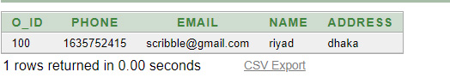

**customer table**

create table customer

(

C_ID number (10) primary key,

NAME varchar2 (10),

BILL_NUMBER number (10))

insert into customer

(C_ID,NAME,BILL_NUMBER)

values ( 200, 'rahul',300)

insert into customer

(C_ID,NAME,BILL_NUMBER)

values ( 201, 'sajan',301)

insert into customer

(C_ID,NAME,BILL_NUMBER)

values ( 202, 'datta',302)

insert into customer

(C_ID,NAME,BILL_NUMBER)

values ( 203, 'saha',303)

insert into customer

(C_ID,NAME,BILL_NUMBER)

values ( 204, 'mahmud',304)

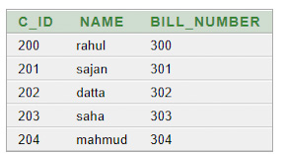

**BILL TABLE**

create table bill

(

BILL_NUMBER number(10) primary key,

DESCRIPTION varchar2 (25),

TOTALAMOUNT number (10),

visit_date varchar2 (15)

)

insert into bill

(BILL_NUMBER,DESCRIPTION,TOTALAMOUNT,VISIT_DATE)

values (300, 'BLACK COFFEE',150, '10-10-10')

insert into bill

(BILL_NUMBER,DESCRIPTION,TOTALAMOUNT,VISIT_DATE)

values (301, ' COLD COFFEE',120, '11-10-10')

insert into bill

(BILL_NUMBER,DESCRIPTION,TOTALAMOUNT,VISIT_DATE)

values (302, ' SUGER FREE COFFEE',110, '12-10-10')

insert into bill

(BILL_NUMBER,DESCRIPTION,TOTALAMOUNT,VISIT_DATE)

values (303, 'HOT COFFEE',100, '13-10-10')

insert into bill

(BILL_NUMBER,DESCRIPTION,TOTALAMOUNT,VISIT_DATE)

values (304, 'WHITE COFFEE',100, '13-10-10')

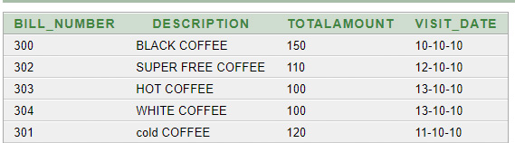

**employee table**

create table employee

(

E_ID number (10) primary key,

NAME varchar2 (15),

ADDRESS varchar2 (15),

EMAIL varchar2 (25),

PHONE number (11),

SALARY number (15),

HIRE_DATE varchar2 (20)

)

insert into employee

(E_ID,NAME,ADDRESS,EMAIL,PHONE,SALARY,HIRE_DATE)

values (500, 'riyad','dinajpur' ,'riyad@gmail.com',01790383988, 10000, '11-10-10')

insert into employee

(E_ID,NAME,ADDRESS,EMAIL,PHONE,SALARY,HIRE_DATE)

values (501, 'rahul','faridpur' ,'rahul@gmail.com',017903835687, 9000, '9-9-9')

insert into employee

(E_ID,NAME,ADDRESS,EMAIL,PHONE,SALARY,HIRE_DATE)

values (502, 'sajan','comilla' ,'sajan@gmail.com',016215835687, 8000, '8-7-9')

insert into employee

(E_ID,NAME,ADDRESS,EMAIL,PHONE,SALARY,HIRE_DATE)

values (503, 'hakim','bogra' ,'hakim@gmail.com',016215834587, 8500, '8-8-9')

insert into employee

(E_ID,NAME,ADDRESS,EMAIL,PHONE,SALARY,HIRE_DATE)

values (504, 'sakib','rajshahi' ,'sakib@gmail.com',016215830007, 7000, '8-8-9')

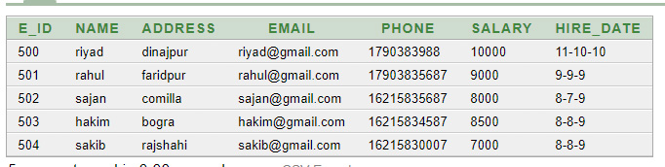

**coffeeshop table**

create table coffeeshop

(

REGI_ID number (10) primary key,

NAME varchar2 (10),

ADDRESS varchar2 (20),

PHONE number (11),

EMAIL varchar2 (25),

O_ID number (10),

C_ID number (10)

)

insert into coffeeshop

(REGI_ID,NAME,ADDRESS,PHONE,EMAIL,O_ID,C_ID)

values (001,'scribble coffee shop', 'dhanmodhi 32 dhaka', 01635752415,'riyadmahmud@GMAIL.COM',100,200)

insert into coffeeshop

(C_ID)

values (201)

insert into coffeeshop

(C_ID)

values (202)

insert into coffeeshop

(C_ID)

values (203)

insert into coffeeshop

(C_ID)

values (204)

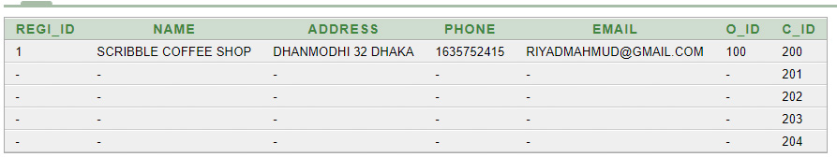

**MANAGER TABLE**

create table MANAGER(

M_ID NUMBER (10),

NAME VARCHAR2 (15),

ADDRESS VARCHAR2 (16),

PHONE NUMBER (10),

EMAIL VARCHAR2 (20),

SALARY NUMBER (10),

O_ID NUMBER (10),

E_ID NUMBER (10))

INSERT INTO MANAGER

(M_ID,NAME,ADDRESS,PHONE,EMAIL,SALARY,O_ID,E_ID)

VALUES (1000,'SCRIBBLE', 'DHANMODHI', 01635752415,'MAHMUD@GMAIL.COM',11000,100,500)

INSERT INTO MANAGER

(E_ID)

VALUES (501)

INSERT INTO MANAGER

(E_ID)

VALUES (502)

INSERT INTO MANAGER

(E_ID)

VALUES (503)

INSERT INTO MANAGER

(E_ID)

VALUES (504)

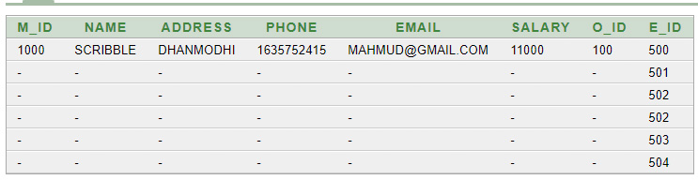

**sub qUARY**

1. **FIND OUT NAME AND SALARY WHOSE SALARY IS GREATER THAN EMPLOYEE ID =503?**

**ANS:**

select name, salary from employee where salary >

( select salary from employee where E_id = 503)

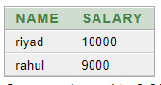

**2.FIND OUT NAME AND SALARY WHOSE SALARY IS THE LOWEST SALARY ?**

**ANS :**

select name, salary from employee where salary >

( select MIN(salary) from employee )

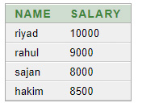

**3. FIND OUT NAME AND SALARY WHOSE SALARY IS GREATER THAN RAHUL’S SALARY?**

**ANS:**

select name, salary from employee where salary >

( select salary from employee WHERE NAME = 'RAHUL')



**JOIN**

**1.FIND OUT OWER NAME ,ID, COFFEESHOP NAME FROM COFFEE SHOP TABLE?**

**ANS:**

select O.NAME,O.O_ID,C.NAME FROM OWNER O, COFFEESHOP C

WHERE C.O_ID=O.O_ID

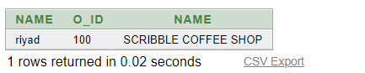

**2.****FIND OUT EMPLOYEE NAME ,SALARY ,ID FROM MANAGER TABLE?**

**ANS:**

select E.NAME,E.E_ID,E.NAME, M.NAME FROM EMPLOYEE E,MANAGER M

WHERE M.E_ID=E.E_ID

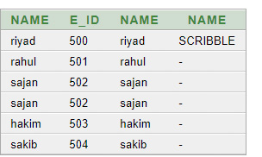

**3.** **FIND OUT CUSTOMER ID AND NAME FROM COFFESHOP?**

**ANS:**

select C.NAME,C.C_ID FROM CUSTOMER C,COFFEESHOP CS

WHERE CS.C_ID=C.C_ID

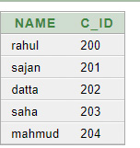

**VIEW:**

CREATE OR REPLACE VIEW RIYAD

AS SELECT REGI_ID , NAME

FROM COFFEESHOP

WHERE C_ID = '500'

**CONCLUSION : THIS PROJECT IS ABOUT ON A COFEEE SHOP MANAGEMENT SYSTERM .THIS IS NOT AN ONLINE BASED SYSTEM. THIS SYSTEM IS CREATE FOR MANAGING A LOCAL COFFEE SHOP WHERE COFFEE SHOP , OWER ,MANAGER ,EMPLOYEE DETAILS ARE INCLUDED AND CUSTOMER ACTIVITIES ARE RECORDER . THIS SYSTEM CAN BE USEFUL FOR A LOCAL COFFEE SHOP WHO WANTS TO RECORD THEIR DAILYS ACTIVITIES .**

